Schneider Department: | AOCI | Document Identification: | AOCI/PMP/RE/T/7
Project Code: | Xxxxxx
Mass Software Upgrade (MSU)

Executive definition & objectives: It is the expression and formalization from the customers needs into offer requirements. It corresponds to customer needs to which we have decided to answer. It is the project reference that becomes the commitment of the project team.

Note: the offer is material or immaterial. It includes product, equipment, solutions, systems, and services, provided by the company to satisfy the customer needs. The retained requirement should be associated to a validation; therefore it should be measurable and controllable.

Deliverable Name | Offer Requirements | Stage Gate
Deliverable Name | Offer Requirements | OPEN
Deliverable Name | Offer Requirements | SELECT
Deliverable Name | Offer Requirements | DO
Deliverable Name | Offer Requirements | IMPLEMENT
Deliverable Name | Offer Requirements | PRODUCE
Deliverable Name | Offer Requirements | SELL
Deliverable Name | Offer Requirements | CLOSE

Status | Draft | In Review | Official

Roles | Function | Name
Authors
Reviewers
Approvers
Refer to applicable Roles Assignment List to fill this table

Template Revision History
Version | Date  dd/mm/yyyy | Author(s) | Modification Details
1.0 | 01/07/2010 | AOCI Quality

Document Revision History
Version | Date  dd/mm/yyyy | Author(s) | Modification Details
00.00 | 20/07/2014 | Pawan Modi | Initial Draft
V1.0 2008/03/18 J.Templeton Fist Official Version Embed final feedback file for Official versions

Linked Documents
Name | Reference | Author | Comments

Show hidden text to read the help (click on standard tool bar command: ¶)

General guidelines to elaborate this document

1. Tailoring the template:
- The template scheme and proposed content intend to help the author in the elaboration of the document: they match our processes definition and way of work and should apply well in most cases.
- Nevertheless, the author has to adapt the proposed content in case of specificities. When some proposed chapters are not applicable, the recommendation is to keep them inside the final document with a short justification of the inapplicability. When extra information is needed, the author is encouraged to structure and document it in the most convenient way.
- In any cases, filling a document rigorously respecting its template is not an objective in itself. It is preferable to reach the intended goal and function of the document than to fit to an inappropriate template scheme.
- A document is appropriate for its intended use if it is:
- Complete: each expected content is present
- Correct: each content is exact
- Consistent: the document fits other related data

2. Updating automated fields:
- Three automated fields must be updated by the author (menu ‘File-Properties-Summary tab):
- The field ‘Title’ is used for the ‘Project Name’
- The field ‘Subject’ is used for the ‘Deliverable Name’ (ex.: “Project Management Plan”, “CANopen Field Bus Product Specification”)
- The field ‘Comments’ is used for the ‘Version’ of the document
- Then update the fields values inside the document:
- Click inside the document
- key CTRL-A (‘Select all’)
- Key F9 to refresh.
- Double-click on page 2 or following Header or Footer
- key CTRL-A (‘Select all’)
- Key F9 to refresh
- The filename of the document is automatically inserted in the document header (ex: “Mirano Project Management Plan.doc”, “CANopen Field Bus Product Specification.doc”)

3. Versioning rules:
Use the following rules to manage the document versions:
- Draft and In Review: vX.X (ex: v0.1, v0.2, v0.3 increment at each published version)
- Official: vX.X (ex: major changes: v1.0, v2.0, v3.0… minor changes: v1.1, v1.2, v1.3…)

4. Filling the Roles table (front page):
Refer to the applicable Roles Assignment List document that gives default Function assignment for Authors, Reviewers and Approvers (stored in the same repository as the documents templates). Keep this table up-to-date for each document Version.

5. Reviewing the document:
- Documents must be reviewed to transform them from the Draft state to the Official state.
- Draft: the document is not mature enough to enter the Review Process
- In Review: the document is in sufficient elaboration level so that Reviewers verify it and decisions are taken for solving found issues (or selection among alternatives)
- Official: the actors of the performed Review Process agreed that the document satisfies the expected quality criteria for its intended use: Completeness, Correctness, Consistency with other project data
- The author (in collaboration with the Project Manager / Review Leader) selects Reviewers and Approvers according to the default Roles Assignment List and involve them in the applicable review process (reference documents are accessible in the Documents Templates repository)
- The final feedback file is preferably embedded inside the Official document (template for Feedback form is accessible in the Documents Templates repository)

6. Template revision history:

Table of Contents
1 Introduction 4
2 Offer Detailed Requirements 4
3 Internal Requirements 5
4 Agency Requirements 8
5 Withdrawal and Consequences 9

Table of Figures

Figure 1: Mass Software upgrade Architecture diagram 4

Introduction
Mass Software Upgrade [MSU] is a reliable network protocol for carrying out simultaneous firmware/software upgrade process of a large number of systems. It uses a combination of multicast and unicast datagram protocols for data transfer. Reliability is achieved by selective re-transmission of the desired portion of the data upon request from the systems participating in the upgrade process.

The objectives of Mass Software Upgrade process are:
- To simultaneously upgrade firmware/software/Application/Files on many systems.
- To encourage indirect or implicit (via programs) use of remote computers.
- To transfer data reliably and efficiently even on high traffic network.
- To Automatic recovery of upgrade process even in cases of network re-establishment.

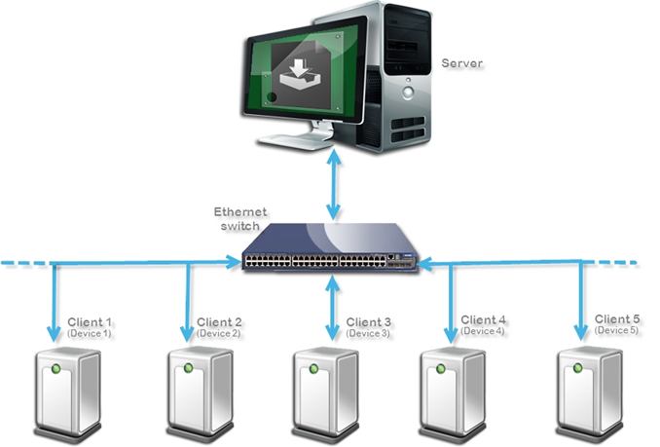
Figure-1: MSU Process Block Diagram

Offer Detailed Requirements

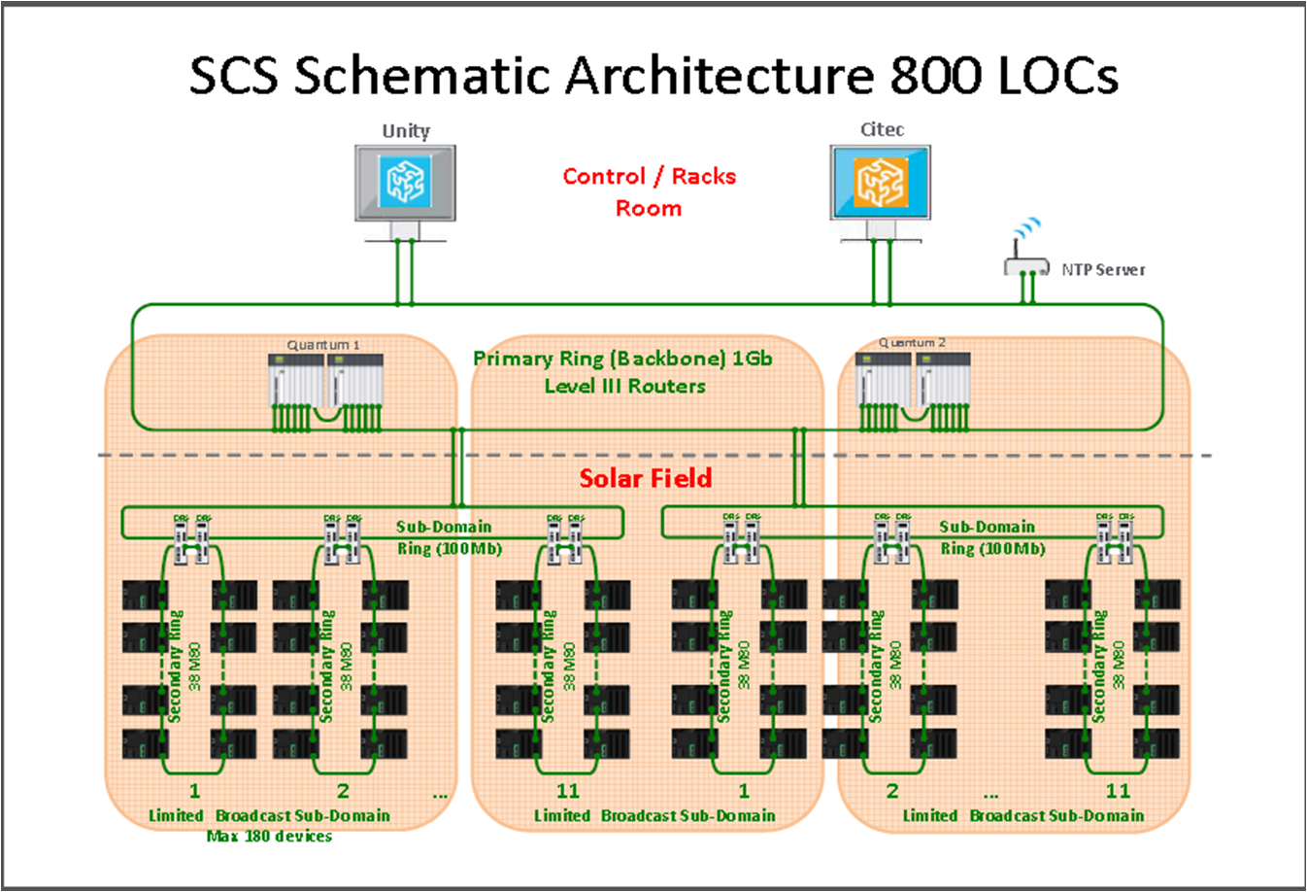
CSP application have large number of devices connected in the network. Such a large network can’t be managed in single network so it is divided into several small networks based on geographic, performance and maintenance. Here is the use case for Mx80 controller for CSP application.
Complete Solar plant divided into many sectors/solar field and each sectors/solar field have many subnets. Each subnet further divided into several rings and one ring can have Max of 38 Mx80 controller. Each subnet can have max 180 Mx80 Controller.
General remarks about Offer Requirements Document
- It is the expression and formalization from the customers needs into offer requirements.
- It corresponds to customer needs to which we have decided to answer.
- It is the project reference that becomes the commitment of the project team.
- Note: the offer is material or immaterial. It includes product, equipment, solutions, systems, and services, provided by the company to satisfy the customer needs.
- The retained requirement should be associated to a means of validation. Therefore it should be measurable and controllable.

In this document the structural MIRs of the Offer functional description are translated into detailed MIRs appropriate to be translated into SRS and linked to Requisite Pro
The Offer requirement document can be initialized during the Investigation and feasibility phase.
The Offer detailed requirements result from the first analysis made during the previous phase (SELECT) by using the “Functional Need Analysis” method and are restricted to the targeted choice corresponding to the selected project scenario.

From the functional analysis derive a precise and unambiguous description by using e.g. Functional Need Analysis method on the targeted choice.

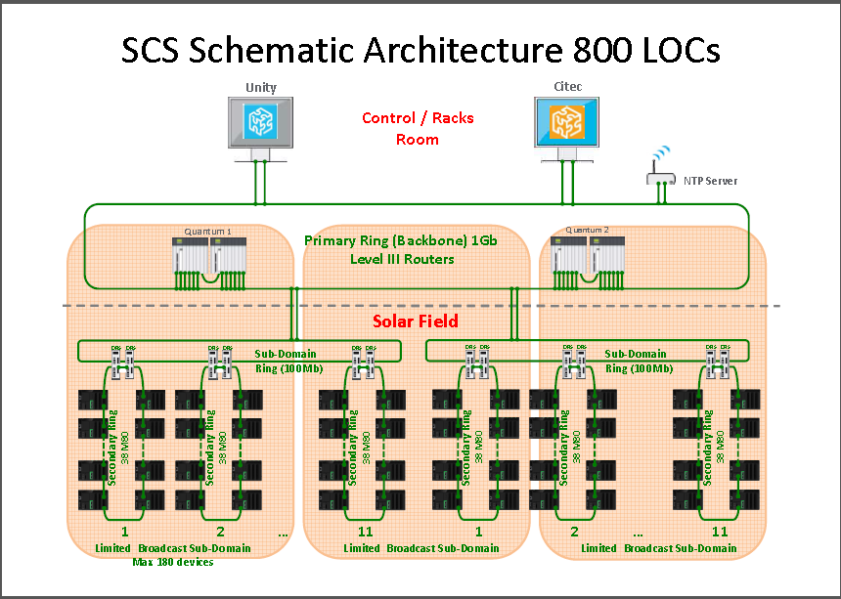

Figure 2: Mass Software upgrade Architecture diagram
MSU is targeting to upgrade one subnet simultaneously

Internal Requirements
- MSU Server
  - Server MUST list all device connected in the network in to “Scan list”
    - Server list device under there groupID. Group ID of non similar device MUST be unique. All similar device MUST fall in same group ID
    - If by mistake or intentionally not done than server should provide the option to regroup the non similar device
    - Server MUST provide option to create the group id of non similar device in case group is not created during commissioning. Group ID MAY be upto 128 SHOULD -:16 MUST-: 4
    - Further Server can list devices under a sub group label as Network ID
    - User can select group to see devices present in this group. Server list all the device by its ID ( IP address)
    - Server MAY scan multiple network in one time in case altogether does not exceed 250 devices . This requirement would be MUST in case of MSU Master where in a network only 1 master will be connected
    - Server MUST scan one network in one time But network size should not exceed 250 device
    - User can further select individual device and see the other information related to this device . Server will get complete detail for every devices in the response packet of Scan command from the devices.
  - Server MUST able to select individual/multiple device from the list
    - MUST have option to provide user ID and Password for Individual/Multiple
    - MUST create separate list of selected device
    - MUST have option to remove selected if needed
    - MUST have option to add more device to selected list from scan list in needed
    - MUST able to back on forth between Scan list and Selected list
  - Server MUST authenticate user ID and Password of selected device from Selected list
    - Server MUST send authentication message to Individual device and allocate a same random number to all for further future communication between server and client
    - User id and password can have option for group level as well
    - Server MUST shows authentication passed and failed status with some kind of signal(symbol )
    - Only the devices participate in current upgrade process those are passed authentication
    - Server can have option to enable and disable user id and password in case architecture do not ask user authentication to perform upgrade process
  - Server MUST able select upgrade file from local/remote drive
    - Server MUST validate selected file : Server compare and validate the Package/File information wrt selected devices and notify to user in case of exception with one or many selected devices.
    - Server MUST Compute MSU protocol parameter : Server have to compute the MSU protocol parameter for selection file. Which will use in Notification message
    - Server SHUOLD have option for auto upgrade notification in case new client version available on remote server
  - Server MUST provide the Configuration screen to provide the configuration information needed by MSU server as well client or process.
    - No of times Notification message need to sends
    - User Id and Password for MSU Server access
    - MUST have edit option for MSU protocol parameters which is collected during network scanning
  - Server MUST restrict the service access @ user level
    - Only Admin/Super user can access all the services
    - Others users MUST only be read only. No service access which allows change in configuration, upgrade process, network/protocol behavior
  - Server MUST download selected file As per MSU specification
    - Server MUST send Notification message to start the upgrade process
    - Server MUST sent Notification message more than one time- No of time MUST be user configurable. This information can be configuration in configuration window
    - Send data packet
    - Retransmission of data packet in case of SCM message from Client
    - Retransmission of data packet in case of CCM message from Client
    - Get the status of each client after finishing process as per MSU specification

- MSU Client
  - Client on Scan command
    - Client MUST respond scan command to server As per MSU Specification
    - Client MUST respond the device identification as per MSU Spec
    - Client MUST respond MSU protocol parameters
  - Client on server and user authenticate
    - Client MUST validate the source of upgrade by IP white listing. Only allow the server those IP address is present in “IP White list”
    - Server IP is not present in “IP White List” than discard the process and send error code Authentication failed do to Server is not list
    - “IP White List” MUST provided in MSU bin file by other mean of configuration tool
    - “IP White List” can be disable during commissioning. In this case Client MUST not validate the source IP address
    - Device MUST support MIN =5 MAX=10 IP address to “IP White List”
    - “IP White List” MUST not be allowed to edit from MSU server.
    - Client MUST validate User ID and Password. Unauthorized user MUST not have access.
    - User authentication can be disable/enable in MSU.bin configuration file.
    - Client MUST not validate the user if user authentication disabled in MSU.bin file
    - Client MUST save transaction ID coming with authentication process to use in future communication with server
  - MSU Configuration
    - All the configuration data required for MSU client MUST be done by some other mean of configuration to prevent from Hacking
    - Client MUST only consume MSU.bin configuration file to configure it self

  - Client group creation
    - Only authenticate user can create the group id
    - Client MUST allow server to create group Id in case non similar device

  - Client Upgrade process
Prior to filling in this chapter please review the Marketing Consistency rules.
- These rules are general Schneider marketing directives approved by the Consistency Steering Committee (CoSC) and define the general direction for a lot of different topics.
- They are accessible either via OCP Portal http://ocp.schneider-electric.com (Function & Skills: Machines & Process Architectures or http://the-village.schneider-electric.com/Business_Efficiency/Marketing/eLib_Mkt.nsf/vF2/AAFR-6GUFSG?opendocument).
- These rules must be checked and applied.

Other aspects of internal requirements to address in this chapter:
- Brand differentiating requirements
- Platform approach / platforming
- Technical invariants from SCo (Internal specification, Software bricks, reused components & technologies)
- Technical choice for Architecture, Transparent Ready (TR) class, Network connectivity, Interoperability, Safety, CET etc. in detail
- Internal standards (Network policy, Design chart, …)
- Environmental objectives (tool: environmental check list)
- Industrialization requirements which could impact the product design
- Internal requirements from the validated MIR requirements list (MIR coming from other functions than marketing)

Agency Requirements
- International standards and norms (UL, IEC, …)
- Legal requirements (CE, …)
- Certification requirements (NEMA, TUF, JIS, …)
- Environmental regulations (European ROHS, WEE, EUP and local regulations)

< Text to write >

Withdrawal and Consequences
- Define the functions and features that will be given up and explain the criteria for the decision made and describe the consequences of this withdrawal.
- Provide the list of POSTPONED and REJECTED MIR requirements (renouncements regarding the initial Offer Functional Description) with the possible impact on customer satisfaction and the business case.

< Text to write >

